主题：网络使用

题型：线图

The line graph below shows internet usage in different countries.

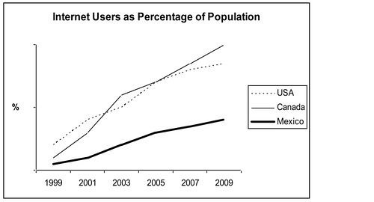

范文：  
  
The line graph compares the percentage of people in three countries who used the Internet between 1999 and 2009.  
  
It is clear that the proportion of the population who used the Internet increased in each country over the period shown. Overall, a much larger percentage of Canadians and Americans had access to the Internet in comparison with Mexicans, and Canada experienced the fastest growth in Internet usage.

In 1999, the proportion of people using the Internet in the USA was about 20%. The figures for Canada and Mexico were lower, at about 10% and 5% respectively. In 2005, Internet usage in both the USA and Canada rose to around 70% of the population, while the figure for Mexico reached just over 25%.  
  
By 2009, the percentage of Internet users was highest in Canada. Almost 100% of Canadians used the Internet, compared to about 80% of Americans and only 40% of Mexicans.